Lab Report

ECPE 170 – Computer Systems and Networks – Spring 2022

Name: Dean Shin

Lab Topic: Performance Optimization (Lab #: 0006)

Question #1:
Describe how a two-dimensional array is stored in one-dimensional computer memory.
Answer:
The two-dimensional array is laid out in memory in row-major order. That is, if the dimension of the 2d array is 3 by 5, that two dimensional array would be laid out in memory as 3 5-element arrays side by side.

Question #2:
Describe how a three-dimensional array is stored in one-dimensional computer memory.
Answer:
If the dimension of the 3d array is 3 by 5 by 7, that three-dimensional array would be laid out in memory as 3 5-by-7 2D arrays side by side.

Question #3:
Copy and paste the output of your program into your lab report, and be sure that the source code and Makefile is included in your compressed folder to submit.
Answer:
Printed out is the row, column, the memory address, and the distance in bytes from where array1[0][0] is located in memory.
Row: 0, Col: 0, Mem: 0x16f1db7b0, Dist: 0
Row: 0, Col: 1, Mem: 0x16f1db7b4, Dist: 4
Row: 0, Col: 2, Mem: 0x16f1db7b8, Dist: 8
Row: 1, Col: 0, Mem: 0x16f1db7bc, Dist: 12
Row: 1, Col: 1, Mem: 0x16f1db7c0, Dist: 16
Row: 1, Col: 2, Mem: 0x16f1db7c4, Dist: 20
It looks like the 2D array is 2 3-long 1d arrays laid out directly next to each other.
Even when the row changes, the distance still increases by 4 bytes.
Printed out is the x, y, z, the memory address, and the distance in bytes from where array2[0][0][0] is located in memory.
x: 0, y: 0, z: 0, Mem: 0x16f1db750, Dist: 0
x: 0, y: 0, z: 1, Mem: 0x16f1db754, Dist: 4
x: 0, y: 0, z: 2, Mem: 0x16f1db758, Dist: 8
x: 0, y: 0, z: 3, Mem: 0x16f1db75c, Dist: 12
x: 0, y: 1, z: 0, Mem: 0x16f1db760, Dist: 16
x: 0, y: 1, z: 1, Mem: 0x16f1db764, Dist: 20
x: 0, y: 1, z: 2, Mem: 0x16f1db768, Dist: 24
x: 0, y: 1, z: 3, Mem: 0x16f1db76c, Dist: 28
x: 0, y: 2, z: 0, Mem: 0x16f1db770, Dist: 32
x: 0, y: 2, z: 1, Mem: 0x16f1db774, Dist: 36
x: 0, y: 2, z: 2, Mem: 0x16f1db778, Dist: 40
x: 0, y: 2, z: 3, Mem: 0x16f1db77c, Dist: 44
x: 1, y: 0, z: 0, Mem: 0x16f1db780, Dist: 48
x: 1, y: 0, z: 1, Mem: 0x16f1db784, Dist: 52
x: 1, y: 0, z: 2, Mem: 0x16f1db788, Dist: 56
x: 1, y: 0, z: 3, Mem: 0x16f1db78c, Dist: 60
x: 1, y: 1, z: 0, Mem: 0x16f1db790, Dist: 64
x: 1, y: 1, z: 1, Mem: 0x16f1db794, Dist: 68
x: 1, y: 1, z: 2, Mem: 0x16f1db798, Dist: 72
x: 1, y: 1, z: 3, Mem: 0x16f1db79c, Dist: 76
x: 1, y: 2, z: 0, Mem: 0x16f1db7a0, Dist: 80
x: 1, y: 2, z: 1, Mem: 0x16f1db7a4, Dist: 84
x: 1, y: 2, z: 2, Mem: 0x16f1db7a8, Dist: 88
x: 1, y: 2, z: 3, Mem: 0x16f1db7ac, Dist: 92
The 3d array looks like it is 2 3 by 4 2D arrays laid out directly next to each other.

Question #4:
Provide an Access Pattern table for the sumarrayrows() function assuming ROWS=2 and COLS=3. The table should be sorted by ascending memory addresses, not by program access order.
Answer:
Mem. Address | 0 | 4 | 8 | 12 | 16 | 20
Mem. Contentes | a[0][0] | a[0][1] | a[0][2] | a[1][0] | a[1][1] | a[1][2]
Program Access Order | 1 | 2 | 3 | 4 | 5 | 6

Question #5:
Does sumarrayrows() have good temporal or spatial locality?
Answer:
The variables j, and sum have good temporal locality as they are accessed in each iteration of the inner loop.
The variable i may or may not have temporal locality depending on how large the COLS constant is. If COLS is small, then i may have temporal locality, but if it is large, then it will not.
The array, a has good spatial locality, but poor temporal locality.

Question #6:
Provide an Access Pattern table for the sumarraycols() function assuming ROWS=2 and COLS=3. The table should be sorted by ascending memory addresses, not by program access order.
Answer:
Mem. Address | 0 | 4 | 8 | 12 | 16 | 20
Mem. Contentes | a[0][0] | a[0][1] | a[0][2] | a[1][0] | a[1][1] | a[1][2]
Program Access Order | 1 | 3 | 5 | 2 | 4 | 6

Question #7:
Does sumarraycols() have good temporal or spatial locality?
Answer:
The variables i, and sum have good temporal locality as they are accessed in each iteration of the inner loop.
The variable j may or may not have temporal locality depending on how large the COLS constant is. If ROWS is small, then j may have temporal locality, but if it is large, then it will not.
The array, a has poor spatial locality and poor temporal locality.

Question #8:
Inspect the provided source code. Describe how the two-dimensional arrays are stored in memory, since the code only has one-dimensional array accesses like: a[element #].
Answer:
Two dimensional arrays are stored in row-major order. That is, each row of elements is directly stored next to each other one after another in memory. For example, a[0][COLS - 1] is directly succeeded by a[1][0]. Therefore, one can access a[1][0] by writing a[COLS] (one after COLS – 1).

Question #9:
After running your experiment script, create a table that shows floating point operations per second for both algorithms at the array sizes listed in Table 2.
Answer:
Floating point ops / second | Algorithm 1 | Algorithm 2
256 | 9.39E+08 | 1.28E+10
512 | 1.90E+09 | 1.30E+10
768 | 2.14E+09 | 1.28E+10
1024 | 1.63E+09 | 1.23E+10
1280 | 2.08E+09 | 1.13E+10
1536 | 1.79E+09 | 1.21E+10
1792 | 1.82E+09 | 1.24E+10
2048 | 6.94E+08 | 1.21E+10

Question #10:
After running your experiment script, create a graph that shows floating point operations per second for both algorithms at the array sizes listed in Table 2.
Answer:

Question #11:
Be sure that the script source code is included in your compressed folder to submit.
Answer:
Done!

Question #12:
processor : 0
vendor_id : GenuineIntel
cpu family : 6
model : 158
model name : Intel(R) Core(TM) i7-8750H CPU @ 2.20GHz
stepping : 10
microcode : 0xde
cpu MHz : 2208.005
cache size : 9216 KB
physical id : 0
siblings : 1
core id : 0
cpu cores : 1
apicid : 0
initial apicid : 0
fpu : yes
fpu_exception : yes
cpuid level : 22
wp : yes
flags : fpu vme de pse tsc msr pae mce cx8 apic sep mtrr pge mca cmov pat pse36 clflush mmx fxsr sse sse2 ss syscall nx pdpe1gb rdtscp lm constant_tsc arch_perfmon nopl xtopology tsc_reliable nonstop_tsc cpuid tsc_known_freq pni pclmulqdq ssse3 fma cx16 pcid sse4_1 sse4_2 x2apic movbe popcnt tsc_deadline_timer aes xsave avx f16c rdrand hypervisor lahf_lm abm 3dnowprefetch cpuid_fault invpcid_single pti ssbd ibrs ibpb stibp fsgsbase tsc_adjust bmi1 avx2 smep bmi2 invpcid rdseed adx smap clflushopt xsaveopt xsavec xgetbv1 xsaves arat md_clear flush_l1d arch_capabilities
bugs : cpu_meltdown spectre_v1 spectre_v2 spec_store_bypass l1tf mds swapgs itlb_multihit srbds
bogomips : 4416.01
clflush size : 64
cache_alignment : 64
address sizes : 45 bits physical, 48 bits virtual
power management:

Question #13:
Based on the processor type reported, obtain the following specifications for your CPU from cpu-world.com or cpudb.stanford.edu
You might have to settle for a close processor from the same family. Make sure the frequency and L3 cache size match the results from /proc/cpuinfo!
(a) L1 instruction cache size
(b) L1 data cache size
(c) L2 cache size
(d) L3 cache size
(e) What URL did you obtain the above specifications from?
Answer:
(a) 192 KiB
(b) 192 KiB
(c) 1536 KB
(d) 9 MB
(e) https://en.wikichip.org/wiki/intel/core_i7/i7-8750h and https://www.cpu-world.com/cgi-bin/IdentifyPart.pl?PART=i7-8750H

Question #14:
Why is it important to run the test program on an idle computer system?
Explain what would happen if the computer was running several other active programs in the background at the same time, and how that would impact the test results.
Answer:
Running on an idle computer is important as if multiple programs are running at the same time, those programs would make use of the computer’s caches. This would mean that the results would be worse, as instead of the singular program having all of the cache available to it, the singular program would have to compete with the other active programs for use of the cache.

Question #15:
What is the size (in bytes) of a data element read from the array in the test?
Answer:
8 bytes

Question #16:
What is the range (min, max) of strides used in the test?
Answer:
min: 1
max: 64

Question #17:
What is the range (min, max) of array sizes used in the test?
Answer:
min: 256 (in bytes, 2 KB)
max: 4194304 (in bytes, 32 MB)

Question #18:
Take a screen capture of the displayed "memory mountain" (maximize the window so it's sufficiently large to read), and place the resulting image in your report.
Answer:
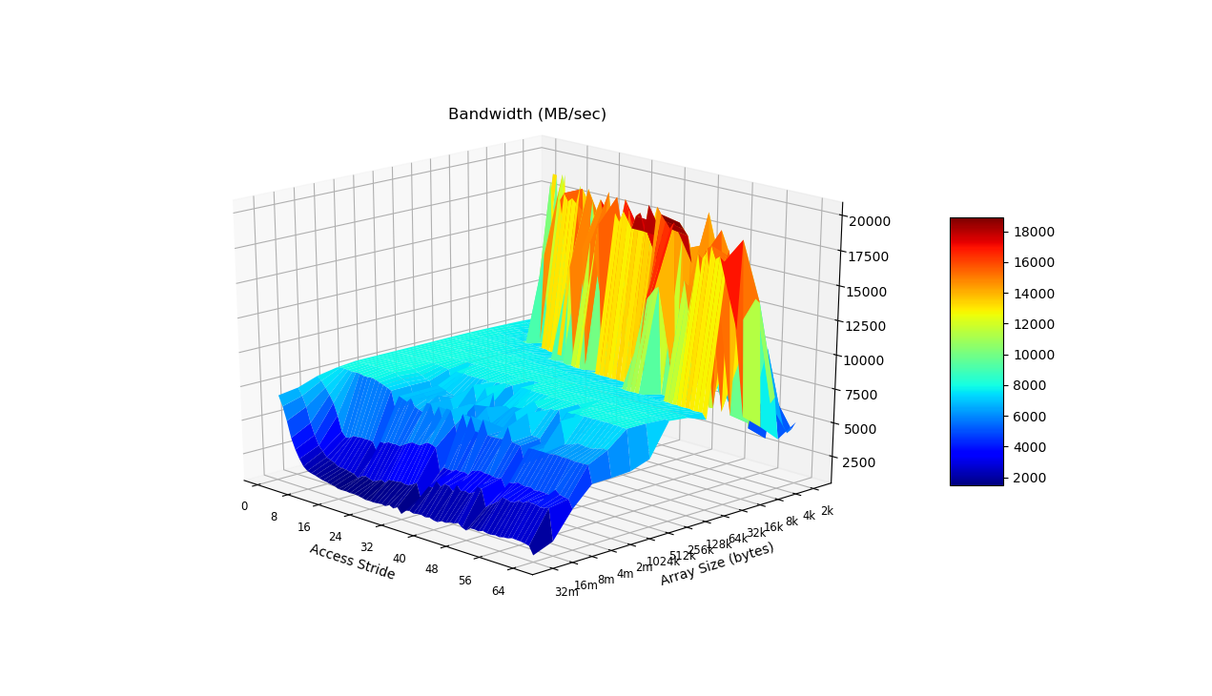

Question #19:
What region (array size, stride) gets the most consistently high performance? (Ignoring spikes in the graph that are noisy results...) What is the read bandwidth reported? Annotate your figure by drawing an arrow on it.
Answer:
The 4k Array Size (in bytes) with a 0-24 stride has the highest performance.
The read bandwidth is around 15000 MB/sec.

TODO: ADD PHOTO

Question #20
What region (array size, stride) gets the most consistently low performance? (Ignoring spikes in the graph that are noisy results...) What is the read bandwidth reported? Annotate your figure by drawing an arrow on it.
Answer:
An array size of over 8MB with an access stride of over 16.

Question #21
Using LibreOffice calc, create two new bar graphs: One for stride=1, and the other for stride=64. Place them side-by-size in the report.
No credit will be given for sloppy graphs that lack X and Y axis labels and a title.
You can obtain the raw data from results.txt. Open it in gedit and turn off Text Wrapping in the preferences. (Otherwise, the columns will be a mess)
Answer:

Question #22
When you look at the graph for stride=1, you (should) see relatively high performance compared to stride=64. This is true even for large array sizes that are much larger than the L3 cache size reported in /proc/cpuinfo.
How is this possible, when the array cannot possibly all fit into the cache? Your explanation should include a brief overview of hardware prefetching as it applies to caches.
Answer:

Question #23
What is temporal locality? What is spatial locality?
Answer:

Question #24
Adjusting the total array size impacts temporal locality - why? Will an increased array size increase or decrease temporal locality?
Answer:

Question #25
Adjusting the read stride impacts spatial locality - why? Will an increased read stride increase or decrease spatial locality?
Answer:

Question #26
As a software designer, describe at least 2 broad "guidelines" to ensure your programs run in the high-performing region of the graph instead of the low-performing region.
Answer:

